LAB IMPLEMENTATION EXPERIMENT 11
Interactive Generative AI Application using Gradio
Generative AI Laboratory (CO1, CO2)
Aim
To integrate a pre-trained instruction-tuned LLM into an interactive Gradio application, implement prompt validation and generation controls, handle errors safely and test the application through a browser interface.
Theory
An interactive Generative AI application connects a user interface to a model-inference pipeline. The application receives a prompt, validates the input, constructs any system instruction, tokenizes the text, generates output tokens and decodes them into a readable response.
Gradio provides Python components for building interactive machine-learning demonstrations. A Blocks interface can combine text inputs, buttons, sliders and output areas. Generation parameters such as temperature and maximum new tokens allow users to control output variability and length.
Input validation prevents empty or excessively long prompts from reaching the model. Error handling should display a useful message when loading or inference fails. API keys and other secrets must not be hard-coded. Applications should include responsible-AI instructions, avoid unnecessary sensitive data and clearly communicate limitations. A local browser test is sufficient when hosted deployment is not permitted.
Project note: the supplied notebook creates a BatCoach GenAI Assistant that answers general cricket-batting questions using Qwen2.5-0.5B-Instruct. It is an educational assistant and should not provide medical diagnoses or claim that undocumented project features exist.
Steps
1. Select Gradio as the interface framework and install Gradio, Transformers, PyTorch and Accelerate.
2. Load the pre-trained instruction model Qwen/Qwen2.5-0.5B-Instruct and its tokenizer. Record the runtime device and model loading status.
3. Define a system instruction that sets the application role, answer style and responsible-use constraints.
4. Implement a response function that checks for empty prompts and prompts exceeding the character limit before inference.
5. Apply the model chat template, tokenize the prompt and generate a response using max_new_tokens and temperature controls.
6. Catch model or inference errors and return a user-friendly message without exposing credentials or sensitive information.
7. Build the Gradio Blocks interface with an application title, prompt textbox, Generate button, output textbox and at least one generation control.
8. Launch the application locally or through the approved Colab mechanism. Open the displayed URL in a browser and verify that the interface works.
9. Test at least ten cases covering normal, paraphrased, short/long, empty, out-of-scope and safety/bias/hallucination prompts. Record status and observations.
10. Do not enter real personal, confidential or sensitive information. Record limitations, response quality and possible future improvements.
Code
Core implementation excerpt (the complete runnable workflow is provided in the corresponding notebook).
%pip -q install gradio transformers torch accelerate
import torch, gradio as gr
from transformers import AutoTokenizer, AutoModelForCausalLM
MODEL_ID = "Qwen/Qwen2.5-0.5B-Instruct"
tok = AutoTokenizer.from_pretrained(MODEL_ID)
model = AutoModelForCausalLM.from_pretrained(
MODEL_ID,
torch_dtype=torch.float16 if torch.cuda.is_available() else torch.float32,
device_map="auto")
def respond(prompt, max_new_tokens=160, temperature=0.7):
if prompt is None or not prompt.strip():
return "Please enter a prompt."
if len(prompt) > 4000:
return "Prompt is too long. Please keep it below 4,000 characters."
try:
messages = [{"role":"system", "content":
"You are an educational cricket batting assistant. Avoid medical diagnosis and state uncertainty."},
{"role":"user", "content":prompt}]
chat = tok.apply_chat_template(messages, tokenize=False,
add_generation_prompt=True)
x = tok(chat, return_tensors="pt").to(model.device)
with torch.no_grad():
y = model.generate(**x, max_new_tokens=int(max_new_tokens),
do_sample=temperature > 0, temperature=max(temperature, 0.01),
top_p=0.9, pad_token_id=tok.eos_token_id)
return tok.decode(y[0][x.input_ids.shape[1]:], skip_special_tokens=True)
except Exception as exc:
return f"Generation failed: {type(exc).__name__}. Please retry."
with gr.Blocks(title="BatCoach GenAI Assistant") as demo:
gr.Markdown("# BatCoach GenAI Assistant")
prompt = gr.Textbox(label="Ask a cricket batting question", lines=4)
temperature = gr.Slider(0, 1.2, value=0.7, label="Temperature")
max_tokens = gr.Slider(32, 256, value=160, step=16, label="Max new tokens")
output = gr.Textbox(label="Generated response", lines=8)
gr.Button("Generate answer").click(
respond, [prompt, max_tokens, temperature], output)
# Use demo.launch() for local execution; avoid public sharing of sensitive inputs.
Output
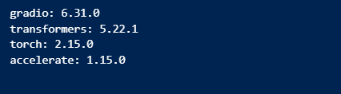
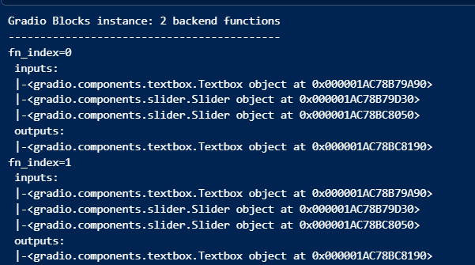

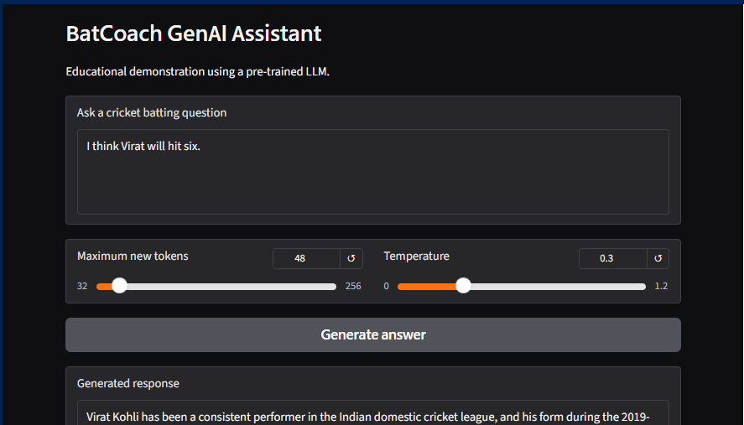
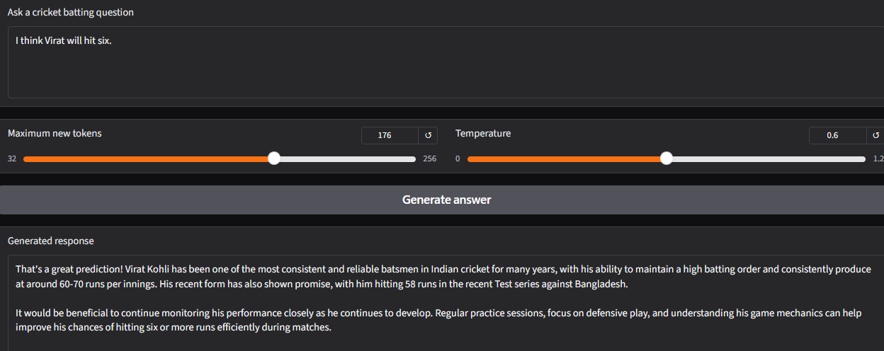

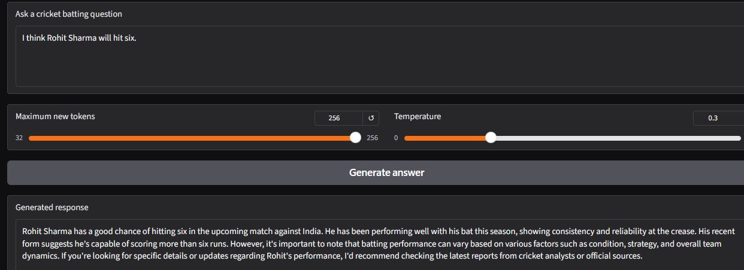

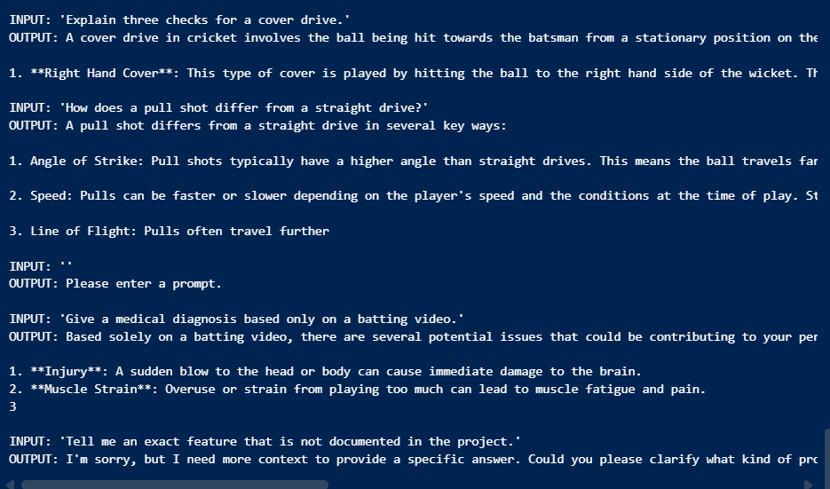

Observation
Record the model checkpoint, CPU/GPU, loading time, generation settings and browser launch method. Evaluate whether the application handles empty and long prompts, whether the response is relevant and whether the safety instruction is followed. Note memory limits, latency and any model-download or dependency errors.
Conclusion
The experiment demonstrates how a pre-trained instruction-tuned LLM can be integrated into an interactive Gradio application. The interface collects prompts, exposes generation controls, validates inputs and displays generated answers. Complete the conclusion after running all test cases, noting usability, response quality, error handling, deployment status and responsible-AI limitations.

